`python app.py`

After the GUI load up,

Open file:

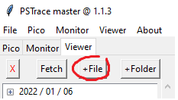

Select the \*.picklez file to open saved data file.

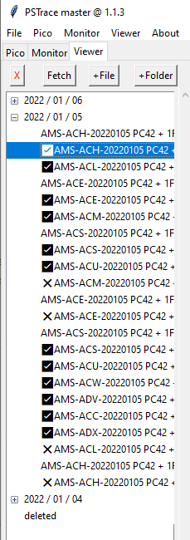

After the file is loaded, you should see a tree structure of all the data.

The check mark or cross mark in front of each data indicates whether the result is positive or negative.

Click the data and you can see the curve of the result.

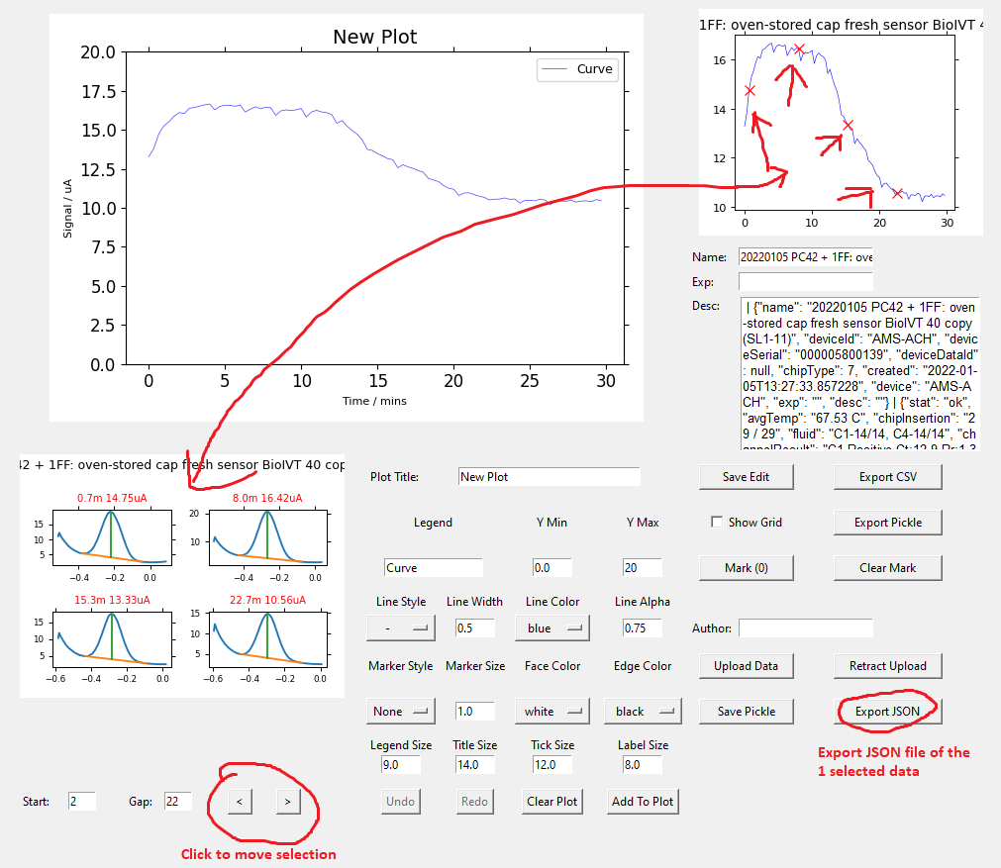

Use the ‘Export JSON’ to export one of the selected data to JSON file, then you can use this file to check out the data processing steps with the Jupyter notebook under ‘dataprocess-demo’ folder.